Automatic Single Head Linear Inner cap and Screw Capping Machine
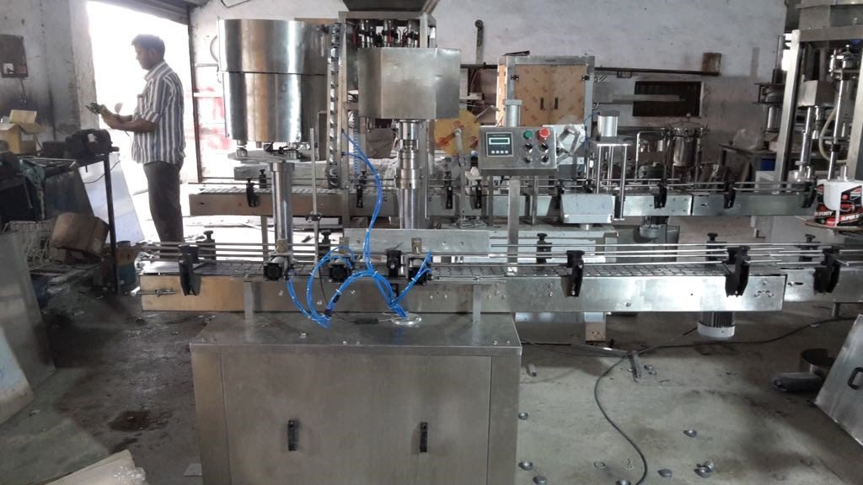

Description
Automatic Screw cap sealing machine is versatile, self-supported on stainless steel leg with height adjustable adjustment system. The machine is precision built on sturdy welded steel frame completely enclose in stainless steel sheet and doors are provided to facilitate the servicing of machine

Operation
The feed container moving on conveyor belt controlled by pneumatic cyilder,while the bottle pick up a cap from the delivery chute of cap feeding bowl, where the body and the neck of the container are positioned below the rotating head, where the sealing head is performing perfect operation of capping.
Technical Specifications
Output/Hour* |  |  |  | 12 to 15 Containers / Min
Direction of Movement |  |  |  | Left to Right
No. of Sealing Head |  |  |  | 1 Nos.
Power Consumption | Main Motor |  |  | 1 HP / 415 Volts / 50 Hz.
 | Cap Feeding Bowl |  |  | 300 watt, Magnetic coil
Height of Conveyor |  |  |  | 860 mm to 910 mm
Machine Dimensions** |  |  |  | 3050 mm (L) x 800 mm (W) x 1850 (H) Approx.
Case Dimensions |  |  |  | 3200 mm (L) x 1100 mm (W) x 2000 (H) Approx.
Net Weight |  |  |  | 350 Kgs. Approx.
Gross Weight |  |  |  | 600 kgs.
Change parts required |  |  |  | (A) Cap Die, Delivery Chute, Bowl
Input Specification
Screw Cap  Specification |  | Diameter** |  | 30 to 50 mm***
 |  | Height** |  | 15 to 18.3 mm
Container Size** |  | Flat / Square |  | 15mm to 100 mm (Length)  Respectively 10mm to 50 mm (Width)  Respectively height 58 mm x 240 mm  (Height option for other bottle height available)
* Depends on bottle size, cap size and type of cap.
** We can supply as per customer requirements.
*** With help of change parts.
Salient Features
- No container No cap arrangement.
- No Change parts required for container change
- All operations are Pneumatic.
- SS elegantly matt finished body.
- Adjustable height of conveyor belt, to align with other machine of the line.
- Sealing pressure can be varied to suit different gauges and size of caps.
- Low noise level, low power consumptions.
- Self-lubricating UHMW-PE guide profile for low friction wears surface, smooth and noiseless conveying.
- SS cladding or hard chrome plating of all exposed parts to ensure long life and resistance against corrosion.
- Adjustable bottle height gauge for easy and quick setting.
Utility Requirement
Electrical supply |  |  | 1 Phase + Neutral + Earthing
Electrical load |  |  | 0.75 KW
Air pressure |  |  | 6 kg required

